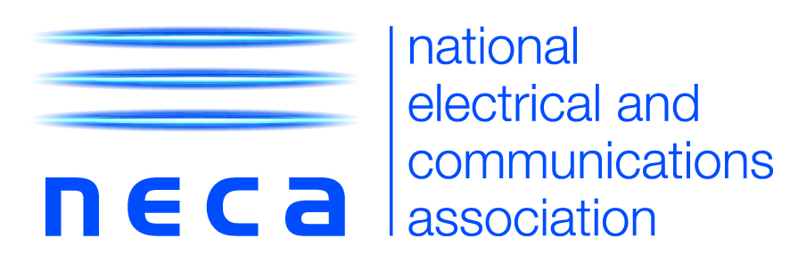

22 May 2020

MEDIA RELEASE

NECA welcomes Government investment in local projects

The National Electrical and Communications Association (NECA) welcomes today’s announcement of $1.8 billion in Government funding to boost road and community infrastructure upgrades that will support Local Government and communities in the COVID-19 recovery phase.

Commenting on the funding announcement, Suresh Manickam, CEO of NECA, said:

“The Government focus on community projects will help to address the immediate need for local jobs, particularly in essential trades such as electrical and communications.

“NECA identified and shared a number of areas for investment with government, and we are pleased that government has listened and recognised the potential of these local community initiatives. A focus on maintenance and upgrades is an investment in local communities that will ensure maximum value can be extracted from local assets.”

“Funding of initiatives such as electrical safety and energy efficiency upgrades to council owned assets such as street lighting, parks and recreational facilities, will not only generate local jobs, but also ensure the future safety and energy efficiency of local communities on the road to recovery”

“This funding is a welcome boost to local economies, as we continue to work with Government at all levels on a number of measures to help protect businesses and jobs, and support the Australian economy as we rebuild following the COVID-19 crisis.

ENDS

NECA media contact
Katherine Cammuso – katherine.cammuso@neca.asn.au or +61 2 410 609 443

Notes for editors
- NECA is the peak industry body representing the interests of electrical and communications contractors Australia-wide.
- Membership comprises approximately 5,400 electrical contractors, employing in excess of 60,000 employees Australia wide.
- NECA provides employment and ongoing skills development for over 4,500 apprentices Australia wide.
- A selection of high-resolution electrical contractor and apprentice insitu images compliant to Standard AS/NZS 4836:2011 are available free by visiting the NECA image library.

